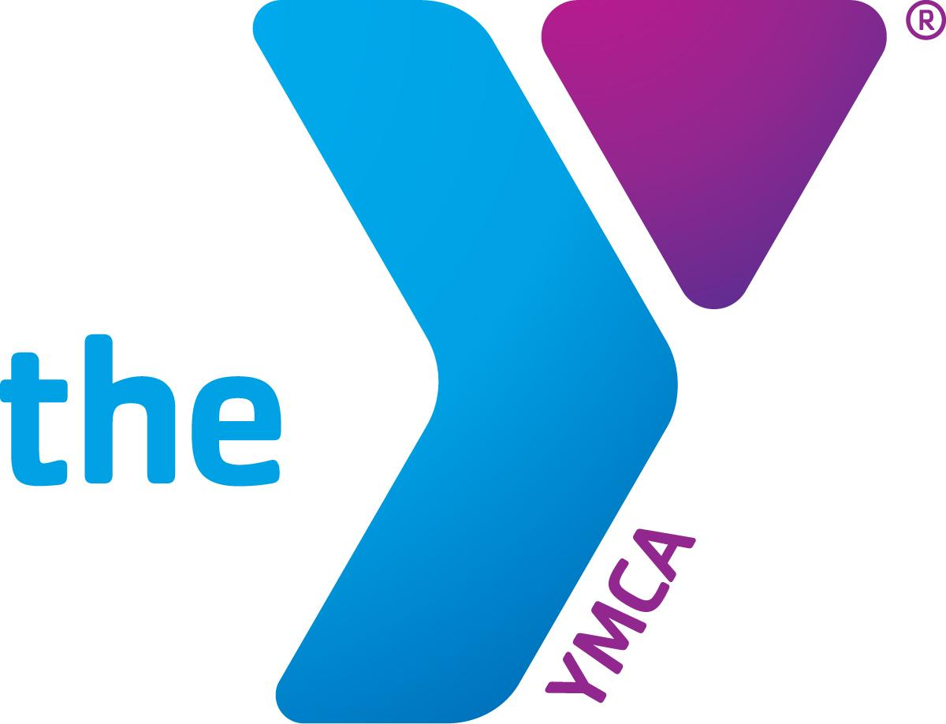

Date

Aloha e XXXX,

On behalf of the YMCA of Honolulu, an organization I am honored to support, I would like you to join me in providing a helping hand, through your donation, to build a vibrant community of resilient youth, thriving kūpuna, and healthy families.

As one of Hawaii’s largest providers of youth and teen programs, the Y plays a vital role in offering our youth mental wellness services to address their growing mental health challenges. With the guidance of our highly-trained Y staff, hundreds of teens receive the help they need from professionals who truly care. **Your helping hand makes this possible.**

With nearly 20% of Honolulu’s population aged 60 and older, the Y serves as a vital space where kūpuna can build lasting friendships, enjoy free meals, improve their mobility through classes, and feel welcome and safe. **Your helping hand makes this possible.**

For working families, financial assistance provides them access to quality early learning programs for their keiki so they can better provide for their loved ones and achieve their full potential. **Your helping hand makes this possible.**

There is no greater joy than knowing your support has enriched someone’s life and filled it with hope. Please join me in making a difference—donate today.

More information about the Y and its programs, please visit <https://bit.ly/YMCAAnnual> or scan:

For your convenience, you may make an online gift at: https://www.ymcahonolulu.org/donate.

Mahalo,

XXXX